**TUGAS 10 MACAM QUERY**

1. SELECT id_obat FROM OBAT;
2. SELECT id_obat, nm_obat, harga_obat from obat;

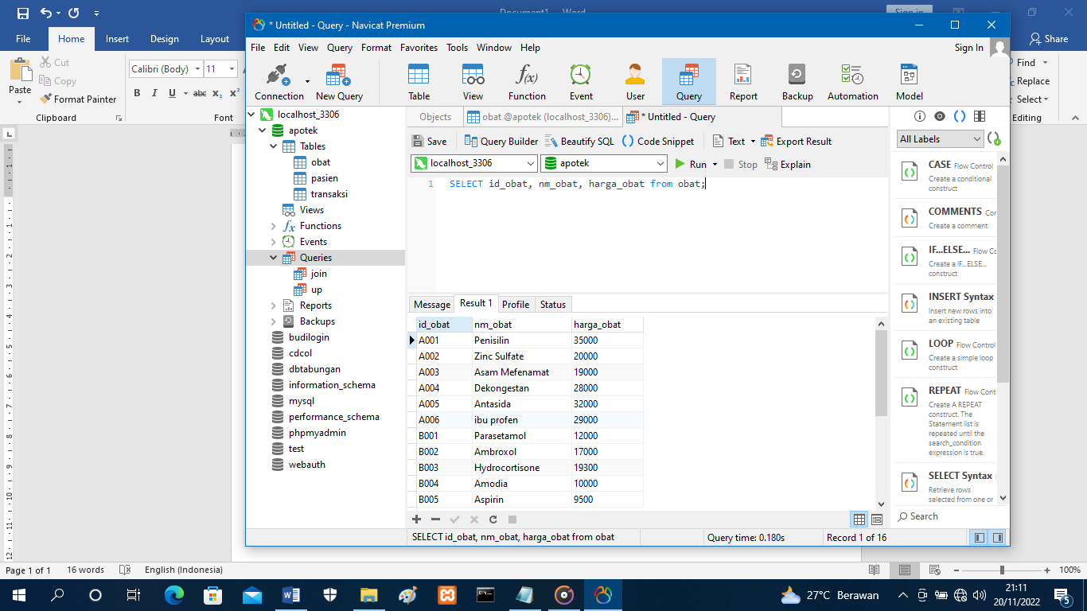

1. 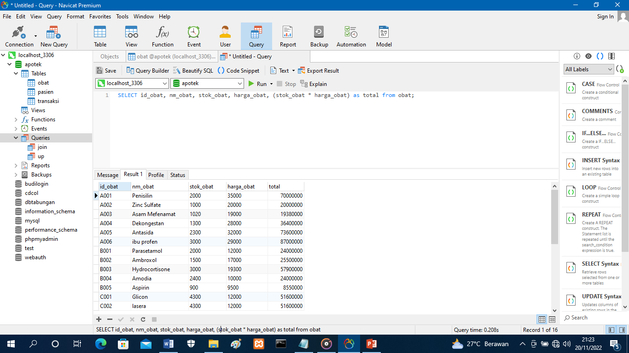SELECT id_obat, nm_obat, stok_obat, harga_obat, (stok_obat * harga_obat) as total from obat;
2. SELECT id_obat, nm_obat, stok_obat FROM obat WHERE stok_obat >2000;

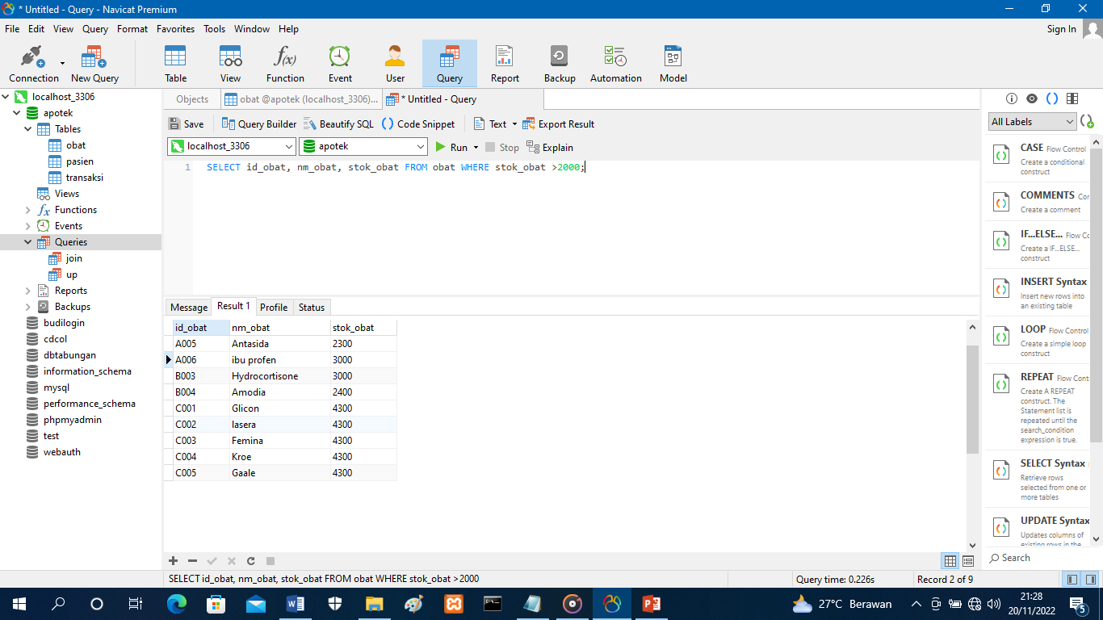

1. select * from obat where stok_obat >3000 order by stok_obat;

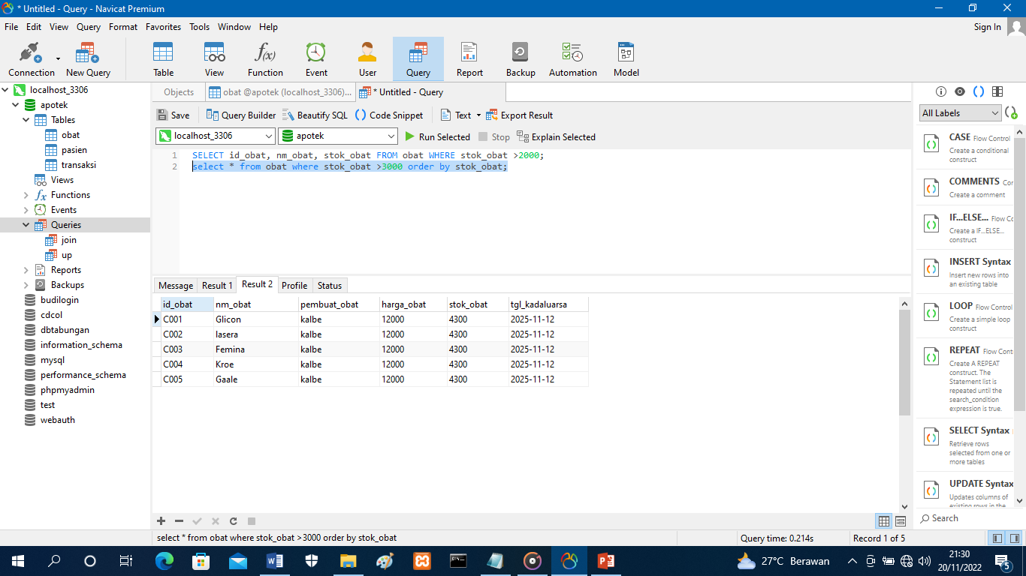

1. select DISTINCT (id_obat) from obat;

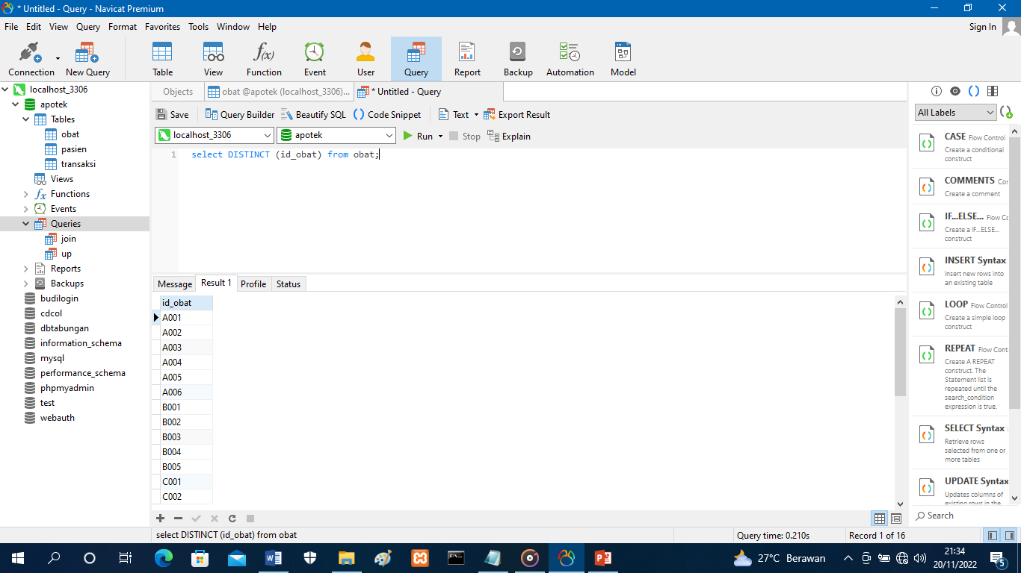

1. select * from obat where stok_obat >= 3000 order by stok_obat;

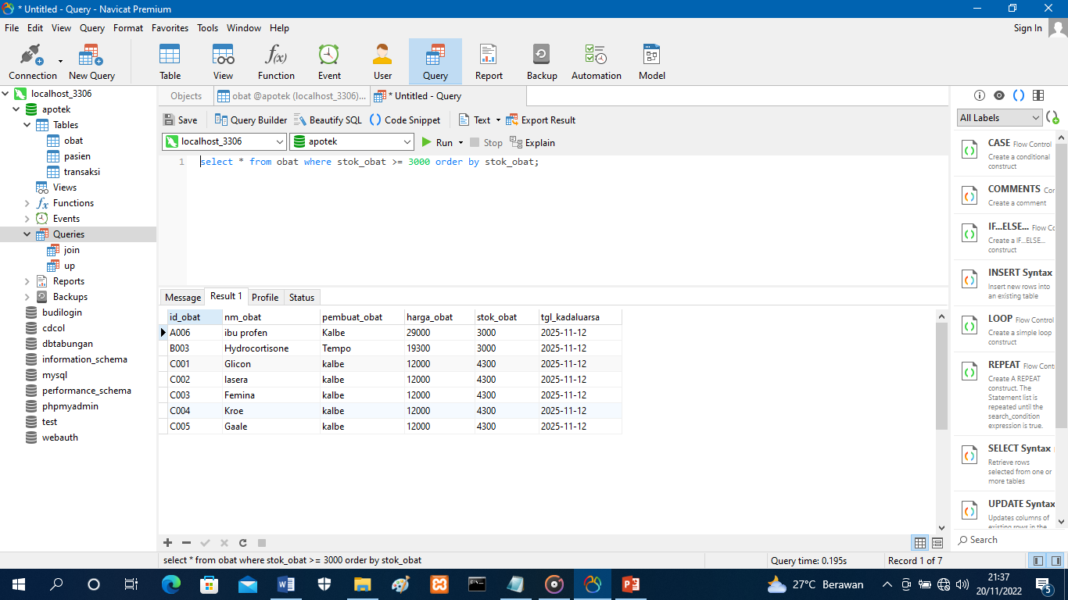

1. select * from obat where harga_obat >= 20000 and stok_obat >=1000;

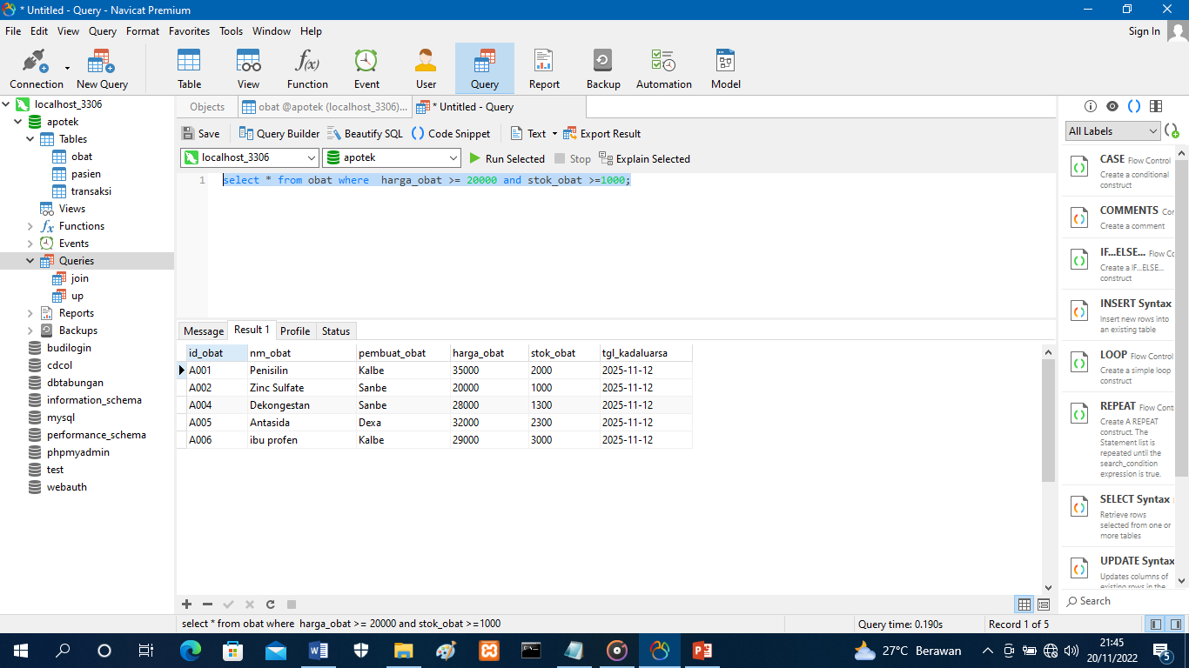

1. select * from obat where harga_obat >= 20000 OR stok_obat >=9000;

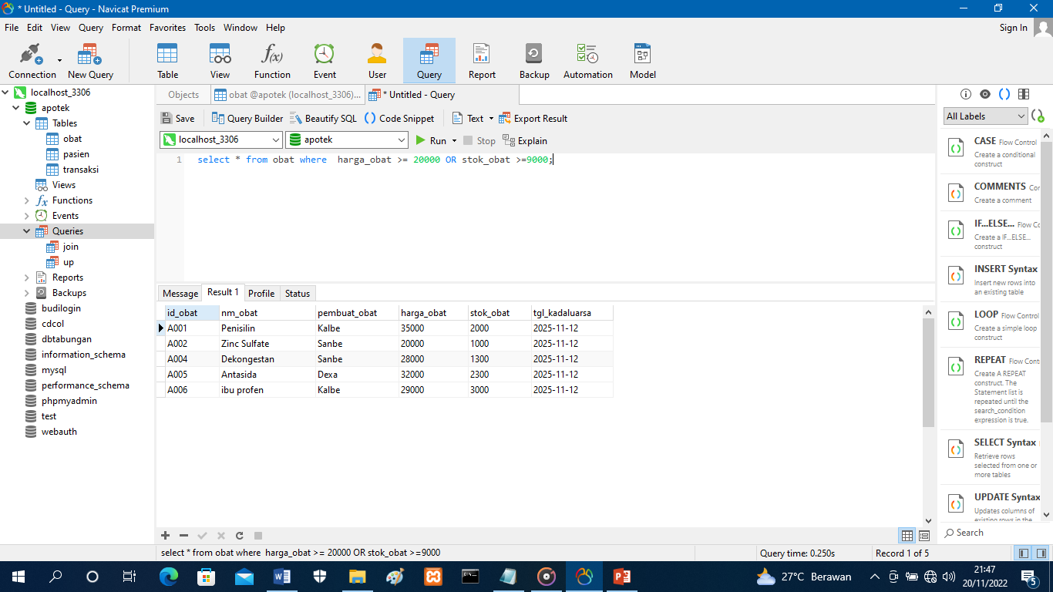

1. SELECT DISTINCT * FROM obat WHERE harga_obat BETWEEN 12000 AND 20000;

